Website Evaluation Tool
Exercise 1
Look the pdf guide to the Heartland Ideas website. Follow the directions on the 4 speech bubbles that appear in the pdf. Use those directions and questions to answer these questions.
Questions To Consider | Responses
Who is the author?
Is his/her job, credentials, or education listed in any way?
Are there many or any experts in the field quoted?
Do we hear from a variety of people or is all the information coming from one source or a small group of sources?
Is there any research studies that have been cited?

When are most of the links dated? Are the dates mostly old or mostly current?
Where is this site mentioned and where are the authors linked to this site published? Is it referenced in any reliable news source (New York Times, CNN, USA Today, academic journal, etc)?
Why do you think the authors wrote this? Is it to help the public, make money, or just to prove something the author feels really strongly about?

Exercise 2: Creating a Gold Standard
Your cousin has heard that you should not drink bottled water that has been sitting in a hot car because plastic bottles leak a toxic substance that increases the drinker’s chance of developing cancer. As breast cancer runs in your family, this is an issue dear to your heart. What characteristics would you want to see (who, what, when, where, why) in a website you would be willing to use to advise your cousin about whether it’s safe to drink the water.

Gold
Star
Standard
Questions To Consider | Responses
Who should the author be?
What would make you trust the author?
What type of information would you like to see in a reliable medical article?
When:
Between what years would you like the research to be dated?
Where?
On what type of website would you like to find this information?
Why?
In reading an article about health, what do you think the author’s main motivation or purpose should have had in writing it?
The Gold Standard

Copy the Gold Standard your class agreed upon in the first column below.

CLASS GOLD STANDARD | HOW YOUR WEBSITE MEETS THIS STANDARD
Who:

What:

Where:

When:

Why:

Activity 3:
Your group will have 15 minutes to choose a website that you believe meets the gold standard for websites set by your class.
- Print out the FIRST page of the website.
- Write down each way your website meets the gold standard in the chart.
- Be prepared to defend why your website meets the Gold Standard; you will earn a point for each Gold Standard met.
- You will lose a point for each Gold Standard not met.
- Groups will gain points when members point out the ways other groups websites did NOT meet the Gold Standard.
THE GROUPS WITH THE MOST POINTS WIN THE PRIZE!!!
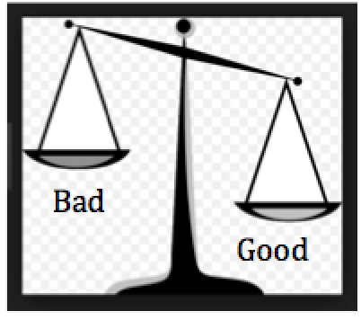
References
- Benjes-Small, C., Archer, A., Tucker, K., Vassady, L., & Resor, J. (2013). TEACHING WEB EVALUATION. Communications In Information Literacy, 7(1), 39-49.

