Artist Report

Element One: Poster

Map of where the artist was born

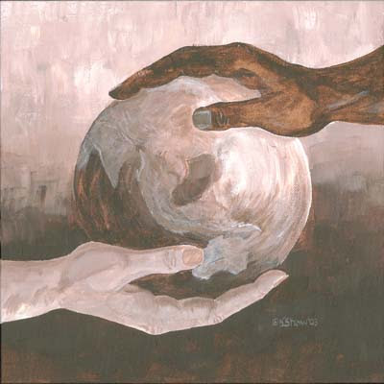

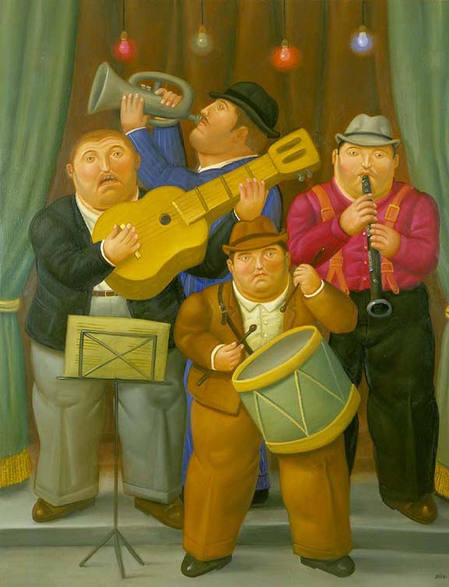

At least three pieces of the artist’s work.

Works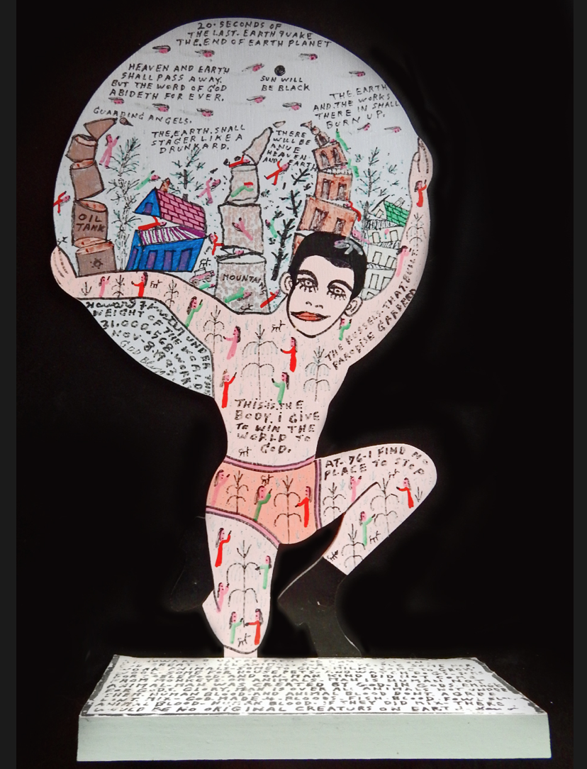

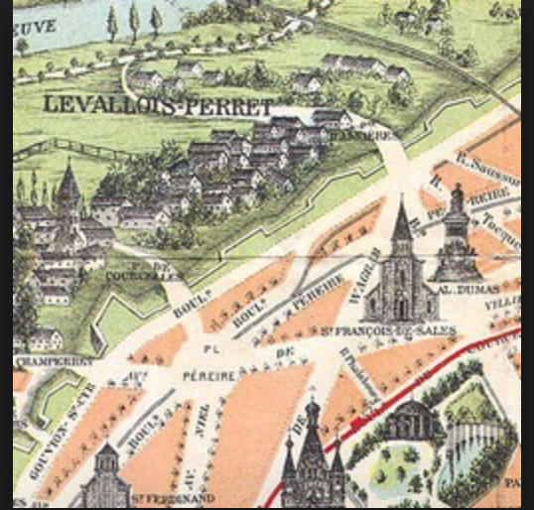

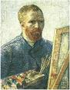

Timeline of artist’s life and work.

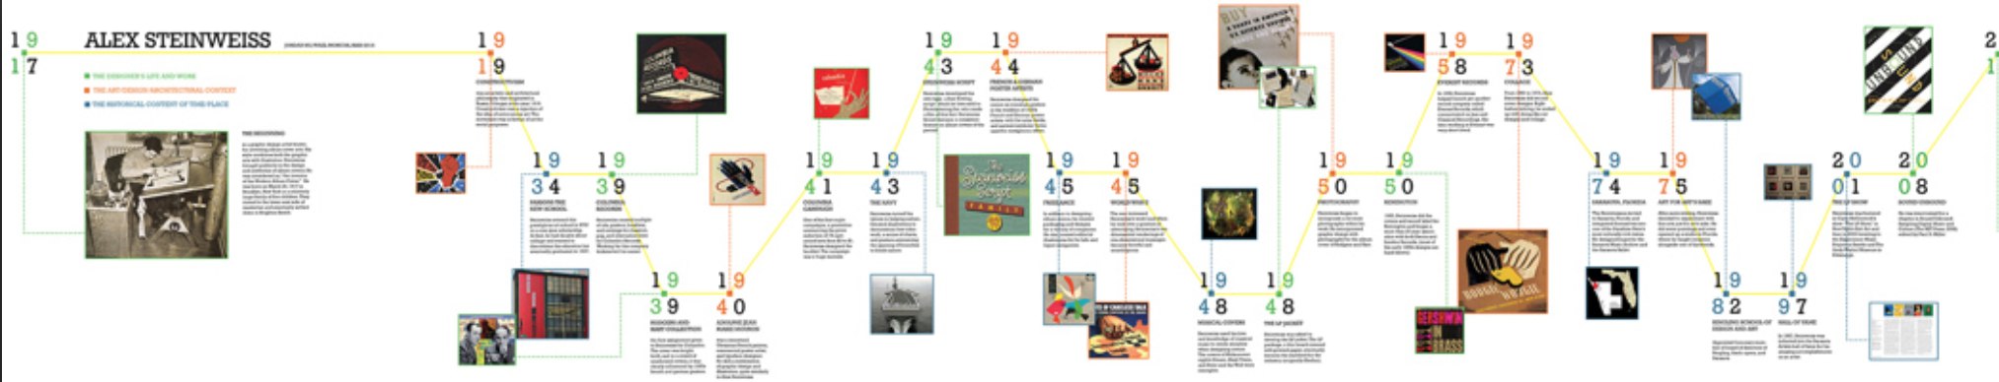

Picture of Artist

aaa

Artist’s Name